|  |
| --- |
|  |
| FlyingWhale Airline  Data Analysis Report |
| |  |  |  | | --- | --- | --- | | Rafia Amir, Rian Qadir, Ramsha Noor, Nauman | 9/29/24 | POWER BI | |

Table of Contents

Executive Summary 2

Introduction to Datasets 2

Flight Activity Analysis: 4

Monthly and Yearly Flight Booking Patterns 4

Correlation Between Flight Distances and Loyalty Points Accumulated 5

Impact of Companion Bookings on Loyalty Points Redeemed 6

Recommendations 7

Loyalty Segmentation: 8

Customer segmentation based on loyalty card status 8

Demographics and behaviors of customers 9

Trends in Customer Lifetime Value (CLV) across loyalty segments 10

Recommendations: 11

Analysis of Enrollment and Cancellation Trends: 12

Recommendations: 18

Conclusion 20

## Executive Summary

This report provides a detailed analysis of FlyingWhale Airline’s customer flight activity, loyalty segmentation, and patterns in customer behavior. By examining flight booking trends, loyalty program performance, and customer demographics, the airline can better optimize its services and marketing efforts. The findings focus on improving customer engagement, loyalty program effectiveness, and enhancing customer satisfaction during peak travel periods.

## Introduction to Datasets

This report is based on two key datasets provided by FlyingWhale Airline. These datasets offer insights into customer flight activity, loyalty points, and demographic details, allowing us to derive meaningful trends and recommendations for enhancing customer experience and loyalty programs. Below is an overview of the datasets:

**1. Customer Flight Activity Dataset**

The **Customer Flight Activity** dataset includes essential data for analyzing the flight patterns of FlyingWhale's loyalty members. It contains:

* **Loyalty Number**: A unique identifier for each customer’s loyalty account.
* **Year and Month**: Time period details, allowing for the analysis of booking patterns over time.
* **Flights Booked**: The total number of flights booked by each customer during the specific period.
* **Flights with Companions**: Number of flights booked where customers traveled with additional passengers.
* **Total Flights**: The combined total of Flights Booked and Flights with Companions.
* **Distance**: Total distance traveled by customers during the period, measured in kilometers.
* **Points Accumulated**: Loyalty points earned by the customer based on the distance traveled and the type of flights booked.
* **Points Redeemed**: Loyalty points redeemed by the customer during the period.
* **Dollar Cost Points Redeemed**: The dollar equivalent value (in Canadian Dollars, CDN) of the points redeemed by the customer.

**2. Customer Loyalty History Dataset**

The **Customer Loyalty History** dataset provides details on customer demographics, loyalty card status, and lifetime value. It includes:

* **Loyalty Number**: A unique identifier for each customer’s loyalty account, allowing for analysis of individual behaviors.
* **Demographics**: Information such as Country, Province, City, Postal Code, Gender, Education, Salary, and Marital Status.
* **Loyalty Card Status**: The current loyalty card tier of each customer (e.g., Star, Nova, Aurora).
* **Customer Lifetime Value (CLV)**: The total invoice value for all flights ever booked by the customer, indicating the long-term value of each member to the airline.
* **Enrollment Details**: Information on how and when the customer enrolled in the loyalty program, including Enrollment Type (e.g., Standard or 2018 Promotion), Enrollment Year, and Enrollment Month.
* **Cancellation Details**: Data regarding membership cancellations, including the year and month when cancellations occurred, if applicable.

These datasets provide the foundation for a detailed analysis of customer behavior, loyalty segmentation, and flight activity trends. The insights derived from them will help FlyingWhale Airline optimize its business strategies and enhance customer loyalty.

## Flight Activity Analysis:

### Monthly and Yearly Flight Booking Patterns

The first stage of the analysis focuses on identifying booking trends at both monthly and yearly levels. Properly naming and sorting the months was critical for ensuring clarity when visualizing seasonal patterns and spikes in flight activity.

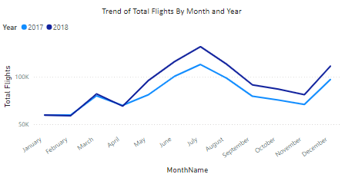

From this analysis, we observe a notable dip in flight bookings during the first quarter of both years. This suggests that the early months of the year tend to be a low-demand period for air travel, likely due to fewer holidays and limited leisure travel. However, after the first quarter, flight bookings in 2018 surpass those of 2017, with a significant peak observed in July, which remains high through September. There is also a resurgence in bookings in December, coinciding with end-of-year holidays.

Our hypothesis, based on these trends, is that leisure travel is a major driver of flight bookings, particularly during school vacations and holiday seasons. Families are more likely to travel during the summer when children are out of school, and holiday seasons provide opportunities for vacations and reunions.

To validate this hypothesis, we gathered holiday data for the country and analyzed its correlation with flight bookings. The chart below illustrates a clear relationship between the number of holidays and the volume of flight bookings with companions.

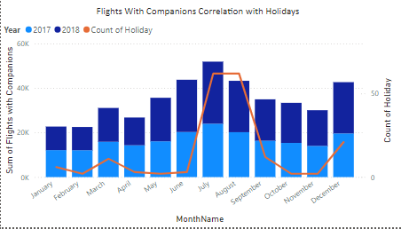

In the graph comparing the total number of holidays per month against the number of flight bookings with companions, we observe a strong positive correlation between the two factors. The data shows that months with more holidays, such as those during the summer and the December holiday season, consistently see an increase in flight bookings. This suggests that travelers are taking advantage of extended breaks to fly, often with companions, during periods of increased leisure time.

The analysis confirms that peak travel periods align closely with major holidays and school vacations.

### Correlation Between Flight Distances and Loyalty Points Accumulated

Our analysis reveals a clear positive correlation: as flight distances increase, so do the loyalty points accumulated by passengers. The included trend line illustrates this relationship, showing that longer flights consistently yield more points.

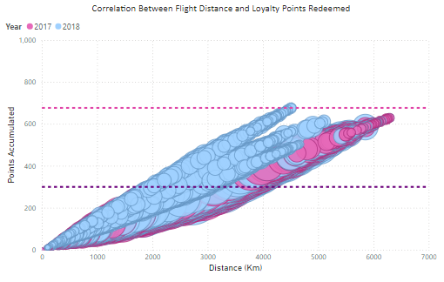

Additionally, the maximum line highlights the peak points awarded for the longest flights, serving as a benchmark for exceptional distance travel. This analysis emphasizes the role of distance in shaping passenger loyalty, allowing Flywhale to better tailor its loyalty program to incentivize longer journeys and enhance customer engagement.

### Impact of Companion Bookings on Loyalty Points Redeemed

In analyzing the effect of companion bookings on loyalty points redemption, we discovered that customers traveling with companions tend to redeem the maximum number of points.

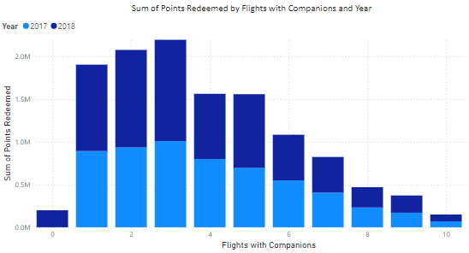

Specifically, individuals flying with a group of three companions redeemed the highest loyalty points, followed closely by those traveling with two and one companion. Interestingly, the redemption rate slightly declines as the number of companions increases, indicating that while group travel generally enhances points redemption, the optimal group size for maximizing point usage appears to be around three.

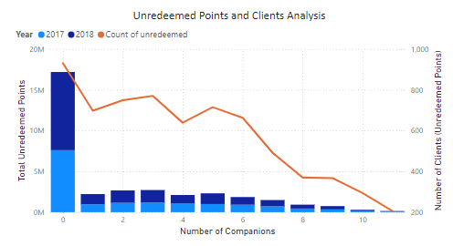

Additionally, we examined clients who are not redeeming their loyalty points despite having accumulated them. Our findings reveal that solo travelers—those flying alone with zero companions—represent the largest group of both unredeemed loyalty points and the number of individuals not utilizing their points.

### Recommendations

The following insights can help Flywhale optimize its promotional offers, loyalty programs, and marketing strategies to align with high-demand periods, potentially increasing revenue and customer engagement:

* Targeted Marketing During Peak Periods: Flywhale should focus its marketing efforts around the summer months and December, as these are peak travel periods. Offering special promotions, discounts for group bookings, or additional loyalty points during these times could significantly boost sales.
* Holiday-Based Promotions: Aligning flight deals and offers with major holidays can attract more travelers. Bundling flights with hotel or travel packages could further encourage longer bookings, enhancing the overall customer experience.
* Enhance Companion Booking Experience: Since companion bookings are strongly correlated with holidays, Flywhale could introduce special perks for travelers flying with companions, such as family discounts, group seating, or loyalty bonuses for group trips.
* Encouraging Point Redemption Among Solo Travelers: The analysis of unredeemed points in relation to the number of companions indicates that a lack of companion travel may lead to lower engagement with the loyalty program. Flywhale has the opportunity to increase point redemption by implementing targeted promotions aimed at solo travelers, encouraging them to utilize their loyalty points more effectively.

## Loyalty Segmentation:

### Customer segmentation based on loyalty card status

FlyWhale Airline has paid special attention to its customer loyalty programs and segmented its customers based on their loyalty card status. There are three types of loyalty cards; Star, Nova, and Aurora. According to the Airline stats, Star is the most premium loyalty card status owned by around 7600 customers, followed by Nova with 5700 customers and then by Aurora with 3400 customers.

When analyzing the pattern of flights taken by loyalty cards across months, it can be seen that July is the busiest month followed by June and August. It is also a consistent pattern that for each month highest customers have the Star status followed by Nova and then Aurora. This may be because most customers find it convenient or preferable to travel in summer as it is usually the time of yearly vacations. Children usually have their summer break and families can travel easily. Another possible reason could be better deals offered by the airline to its loyal customers during these months.

The least number of flights are taken in the months of January and February. The weather may be playing a role here. Rain and heavy snowfall hinder regular flight activity. Moreover, it is the time when children have their schools on.

### Demographics and behaviors of customers

According to the demographics, the highest proportion of customers holding loyalty cards are married i.e., about 58%. This is followed by single individuals (26.7%) and then by Divorced (15%). There is no drastic difference in terms of flights booked by loyalty card holders across genders. Generally, males holding Star and Aurora cards book a greater number of flights whereas from Nova cards females booked more.

To study the median distance traveled by different loyalty card tiers, it is evident that star card status holders have traveled the largest distance in km, followed by Aurora, and then Nova. However, it is interesting to note that the difference in the distance traveled does not reciprocate with the percentage of difference among several card holders. This means that even though there are way more star holders than Aurora, they travel shorter distances overall in comparison to Aurora cardholders. This may also be because since Star is the premium status, they get direct flights (thus having to travel shorter distances). Aurora is the lower in the status hierarchy and therefore its customers might be given connecting flights, thus greater distance and time.

### A graph of a number of blue rectangular objects Description automatically generatedTrends in Customer Lifetime Value (CLV) across loyalty segments

Customer Lifetime Value (CLV) is a metric that estimates the total revenue a business can expect from a single customer throughout their entire relationship with the company. It considers various factors, including:

* Average Purchase Value: The average amount spent by a customer per transaction.
* Purchase Frequency: How often a customer purchases within a given period.
* A graph with a line

  Description automatically generatedCustomer Lifespan: The average duration a customer continues to buy from the company.

According to the given stats, it is interesting to note that Aurora cardholder status contributes this most in CLV followed by Nova and then Star. This means despite Star status being premium status and probably providing the best services and convenience, the customers of Aurora are the ones contributing most on average to the company’s CLV. This means there is a need to direct more attention to Aurora cardholders and they greatly contribute to the company’s earnings.

### Recommendations:

* Consider the value of different customer segments, and tailor the marketing efforts and quality of services to focus on high-value customers, which is the Aurora cardholders in this case. This shall optimize their return on investment.
* Provide better offers to Aurora cardholders where they can also travel on direct flights which will save them time and they’ll travel less distance. This may lead to further customer satisfaction and thus greater return.
* Special discounts should be offered in low-performing months when fewer flights are booked. This may help in increasing the overall revenue of the company throughout the year.

## Analysis of Enrollment and Cancellation Trends:

This analysis dives deep into the enrollment and cancellation patterns of loyalty card members. The goal is to identify the key drivers behind membership cancellations, the demographics most affected, and the trends associated with the enrollment and cancellation behavior over time. Through this analysis, we will also answer key questions regarding cancellation patterns by province, most popular cancellation months, and enrollment duration by demographic factors.

*Figure 1: Average enrolment duration before cancellations*

The average duration of enrollment among canceled members provides insight into how long members stay active before deciding to cancel. From the analysis, we observed that Prince Edward Island has the shortest average enrollment duration among canceled members, with members canceling after an average of 12.4 months (Figure 1)

*Figure 2: Average enrolment duration before cancellation province wise*

New Brunswick sees members staying longer before canceling, with an average duration of 19.2 months (Figure 2).

*Figure 3: Membership cancellations province wise*

Based on the analysis, Ontario stands out as having the most cancellation rate i.e. 0.37 billion (Figure 3).

*Figure 4:Monthly cancellations (Annual)*

A breakdown of cancellations by month reveals that certain periods of the year experience higher cancellation rates than others. The graph shows that August, December and November see the highest number of cancellations. This could be linked to seasonal factors, where customers evaluate their memberships in around mid and at the end of current year or before the beginning of the next year, possibly as part of a broader review of their spending or commitments to travelling activities. The month of May also shows a spike in cancellations after April, which might be related to changes in travel patterns or financial planning around summer vacations. The graph also indicates that cancellations have increased in the recent time (year of 2018) with the lowest amount of cancellations in 2013 (Figure 4).

*Figure 5: Demographic analysis of cancellation (education and marital status)*

The demographic analysis of cancellations based on education and marital status offers valuable insights into which groups are most likely to cancel their memberships (Figure 5). Members with a bachelor's level of education and who are married have the highest rate of cancellations. Overall members with master's, doctorate, and high school degrees display more loyalty, with low cancellations. However, among them, married customers have the highest cancellation rate. Members with college degrees is the second highest category in terms of cancellations and within this category single people show the most cancellations.

Married members with a bachelor's education level and single with college degrees are the most frequent cancelers. This demographic might be more price-sensitive or have different service expectations that aren't being met, indicating the need for more tailored marketing and retention strategies.

The analysis of loyalty card types reveals that certain types of cardholders cancel their memberships more than others: Aurora cardholders have the lowest cancellations followed by Nova and Star cardholders have the highest cancellations (Figure 6).

Figure 6: Cancellation analysis (loyalty card type)

*Figure 7: Enrolment (gender wise)*

The graph shows that female members slightly outnumber male members in terms of enrollment (Figure 7). However, cancellations seem to be balanced across genders displaying that overall, married males with bachelor’s degrees and married females with bachelor’s degrees are more inclined towards canceling their membership (Figure 9 and Figure 6). The results imply that gender is not a significant factor in determining either enrolment or cancellation behavior.

*Figure 8: Cancellation analysis for Males (education and marital status)*

*Figure 9: Cancellation analysis for Females (education and marital status)*

*Figure 10: Enrolment overtime (loyalty card type)*

The enrollment trend has been generally positive for all card types with Star having the most enrolments followed by Aurora and Nova. Star loyalty card type experiences a peak in May and a dip in June with a slight increase followed by a decreasing and stagnant trend from (September to December). Nova loyalty experiences a dip in enrolments in August with a gradual increase till December. Aurora loyalty experiences a dip in February after which the enrolment sees a gradual increase. This is possible due to external factors such as holidays or economic conditions affecting differently on different loyalty types.

### Recommendations:

By addressing these factors, the organization can strengthen member loyalty and reduce the overall cancellation rate.

* Provinces with decreasing enrollment durations and high cancellations could look into issues such as dissatisfaction with services, unmet expectations, or market-specific factors influencing membership retention. It is recommended to implement targeted marketing campaigns aimed specifically at high-cancellation provinces. Utilize data analytics to understand why members in these regions are canceling and tailor campaigns that address their specific pain points (e.g., dissatisfaction with service, value perception). Consider promotional offers, special events, or enhanced customer support tailored to these areas.
* The Monthly analysis of cancellations reveals that seasonal factors influence the spending commitments of customers. The peak months for cancellations could be an opportunity to proactively engage with members through targeted retention campaigns, offering personalized benefits or incentives to encourage them to stay.
* Married members with a bachelor's education level and single with bachelor's and college degrees (respectively) are the most frequent cancelers. This demographic might be more price-sensitive or have different service expectations that aren't being met, indicating the need for more tailored marketing and retention strategies. Revise the benefits associated with basic-tier loyalty cards to improve perceived value. Introduce attractive incentives for such members, such as exclusive discounts, bonus points for early renewals, or referral rewards. Conduct surveys to understand what benefits would appeal most to this demographic.
* The lower enrollment duration for Aurora members may indicate that these members do not find the value they are looking for in the loyalty program. The organization could consider offering enhanced perks or creating a loyalty ladder that encourages members to upgrade to higher tiers with better rewards and incentives for retention.
* Develop personalized communication plans to engage at-risk members, particularly single college-educated and married bachelor-educated individuals. Use customer segmentation to create targeted emails or notifications highlighting benefits relevant to these groups. For example, share tips on maximizing loyalty points, personalized offers, or updates on membership benefits that cater specifically to their needs.
* Foster community and engagement among members through events, webinars, or online forums. Host regular engagement activities such as informational webinars on maximizing membership benefits, Q&A sessions, or community-building events that encourage participation. This will help members feel more connected to the brand and less likely to cancel.
* Implement robust feedback mechanisms to gather insights from members about their experiences. Given that cancellations have increased in recent years, the company needs to create regular surveys or feedback loops that allow members to share their experiences and suggestions regarding the loyalty program to retain customers over time.

## Conclusion

This report has conducted a comprehensive analysis of FlyingWhale Airline's customer flight activity, loyalty segmentation, and enrollment patterns, revealing critical insights that can guide the airline in enhancing its services and marketing strategies. The analysis highlights the significant impact of seasonal travel trends, the importance of companion bookings, and the varying behaviors of loyalty program members.

By aligning marketing efforts with peak travel periods, introducing targeted promotions, and tailoring the loyalty program to meet the needs of different customer segments, FlyingWhale can optimize customer engagement and loyalty. Additionally, understanding the drivers behind membership cancellations can help the airline implement effective retention strategies, ensuring long-term customer loyalty and satisfaction.

In summary, by leveraging these insights and recommendations, FlyingWhale Airline can enhance its competitive edge, improve customer experience, and ultimately drive revenue growth.